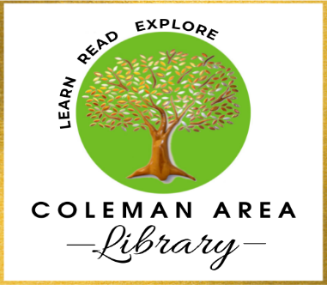

Request For Reconsideration
of Library Material

Our Mission: The Coleman Area Library is dedicated to the cultural and educational spirit of the community, the Library is committed to providing public access to information and materials regardless of format for library patrons with friendly, competent, accurate and expedient service. Library materials and services encourage life-long learning, act as a catalyst for the free exchange of ideas and promote literacy among all people regardless of race, religion, creed or color or national origin.

The Library Board of Directors has delegated the responsibility for selection and evaluation of collection materials to the Library Director and has established reconsideration procedures to address concerns about those resources.

Completion of this form is the first step in those procedures. If you wish to request reconsideration of library materials, please return a completed form c/o the Library Director, Coleman Area Library, 111 First St. P.O. Box 515, Coleman, MI 48618

Only forms that are 100% completed will be accepted. The Library Director has up to sixty (60) days to complete the reconsideration process for each form. The material being reconsidered must be read in full by the applicant.

Name: _____________________________________ Date: __________________________

Address: _____________________________________________________________________

City: _______________________ State: _________ Zip code: _______________________

Phone: __________________________ Email: _____________________________________

Are you a Coleman Area Library cardholder or do you live in our service area?
Yes ______ No ______

Who do represent? Self _______ Organization _______

If organization, please provide the name: __________________________________________
Material to be considered
Title:________________________________________________________________________

Author:________________________________ Type of Material: _______________________
(Artist, Performer, etc.) (Book, DVD, Program, etc.)

Did you read, view, or listen to the entire work? Yes _____ No _____

Have you read any professional reviews of this work? Yes _____ No _____

If yes, please list publication(s) here:

______________________________________________________________________________

______________________________________________________________________________

What do you believe is the major theme or intent of this work?

______________________________________________________________________________

______________________________________________________________________________

What is your objection to this work? Please be specific. _________________________________

______________________________________________________________________________

______________________________________________________________________________

What do you feel might be the result of reading, viewing, or listening to this work?

______________________________________________________________________________

______________________________________________________________________________

What action do you wish to be taken?

______________________________________________________________________________

Please explain how such an action would improve the Library’s service to the community:

______________________________________________________________________________

______________________________________________________________________________

In its place, what work of equal literary quality would you recommend the Library purchase that would cover the same subject or content?

______________________________________________________________________________

______________________________________________________________________________

______________________________________________________________________________

___________________________________ _____________________________________

Signature Date

Completed forms should be delivered to:

Coleman Area Library
Attn: Library Director
111 First St. P.O. Box 515
Coleman, MI 48618

Approved by the Coleman Area Library Board July 18, 2023

